SIMPLE MOOD & WELLNESS JOURNAL
@CREATIVITY THINK (9483175986/7019689991)

ABSTRACT:
Simple Mood & Wellness Journal is a web-based application designed to help individuals track their daily moods, emotions, and wellness habits. The platform allows users to log their mood using emojis or scales, add emotion tags and notes, monitor journaling streaks, visualize trends over time, and receive self-care tips. Administrators manage emotion tags and tip content, review anonymized trends, moderate shared posts (if enabled), and export aggregate statistics. Built with Django and Django REST Framework for backend services, and React with recharts and axios for frontend interactivity, the system provides a secure, user-friendly environment for personal wellness tracking and data-driven insights..

INTRODUCTION OF THE PROJECT:
Maintaining a consistent mood and wellness journal is challenging without a structured digital system. Traditional pen-and-paper methods are prone to loss, lack visual analytics, and do not offer reminders or trend tracking. Simple Mood & Wellness Journal addresses these limitations by providing a centralized web application that enables users to log emotions, track patterns, and receive personalized self-care suggestions. Administrators gain insight into anonymized mood trends to improve engagement and content while maintaining privacy..

PROJECT OBJECTIVES:

• Enable users to log daily moods with emoji or scale ratings
• Allow adding emotion tags and optional notes for detailed tracking
• Provide journaling streak tracking to encourage consistency
• Display trend charts for weekly and monthly mood visualization
• Share random self-care tips to enhance user wellness
• Allow administrators to manage emotion tags and self-care content
• Moderate shared community posts, if the feature is enabled
• Export aggregate statistics and trends for insights
• Provide a secure, intuitive, and scalable wellness platform

PROBLEM OF THE STATEMENT:
Individuals often lack an easy-to-use, structured platform to consistently log mood and wellness data. Traditional methods are static, difficult to analyze, and fail to provide insights or motivation for ongoing journaling. Administrators in counseling centers or wellness programs also struggle to view anonymized trends and manage wellness content effectively. This project solves these problems by providing a secure, interactive, and analytic-enabled environment for both users and administrators..

MOTIVATION OF THE PROJECT:
• To facilitate daily mood and wellness tracking
• To promote emotional awareness and self-care habits
• To provide visual insights through trend charts
• To encourage consistent journaling through streak tracking
• To offer administrators tools to manage content and monitor anonymized trends
• To support individual wellness and counseling programs
• To create a user-friendly, accessible digital platform
• To integrate self-care guidance into daily habit tracking

BLOCK DAIGRAM OF PROJECT:

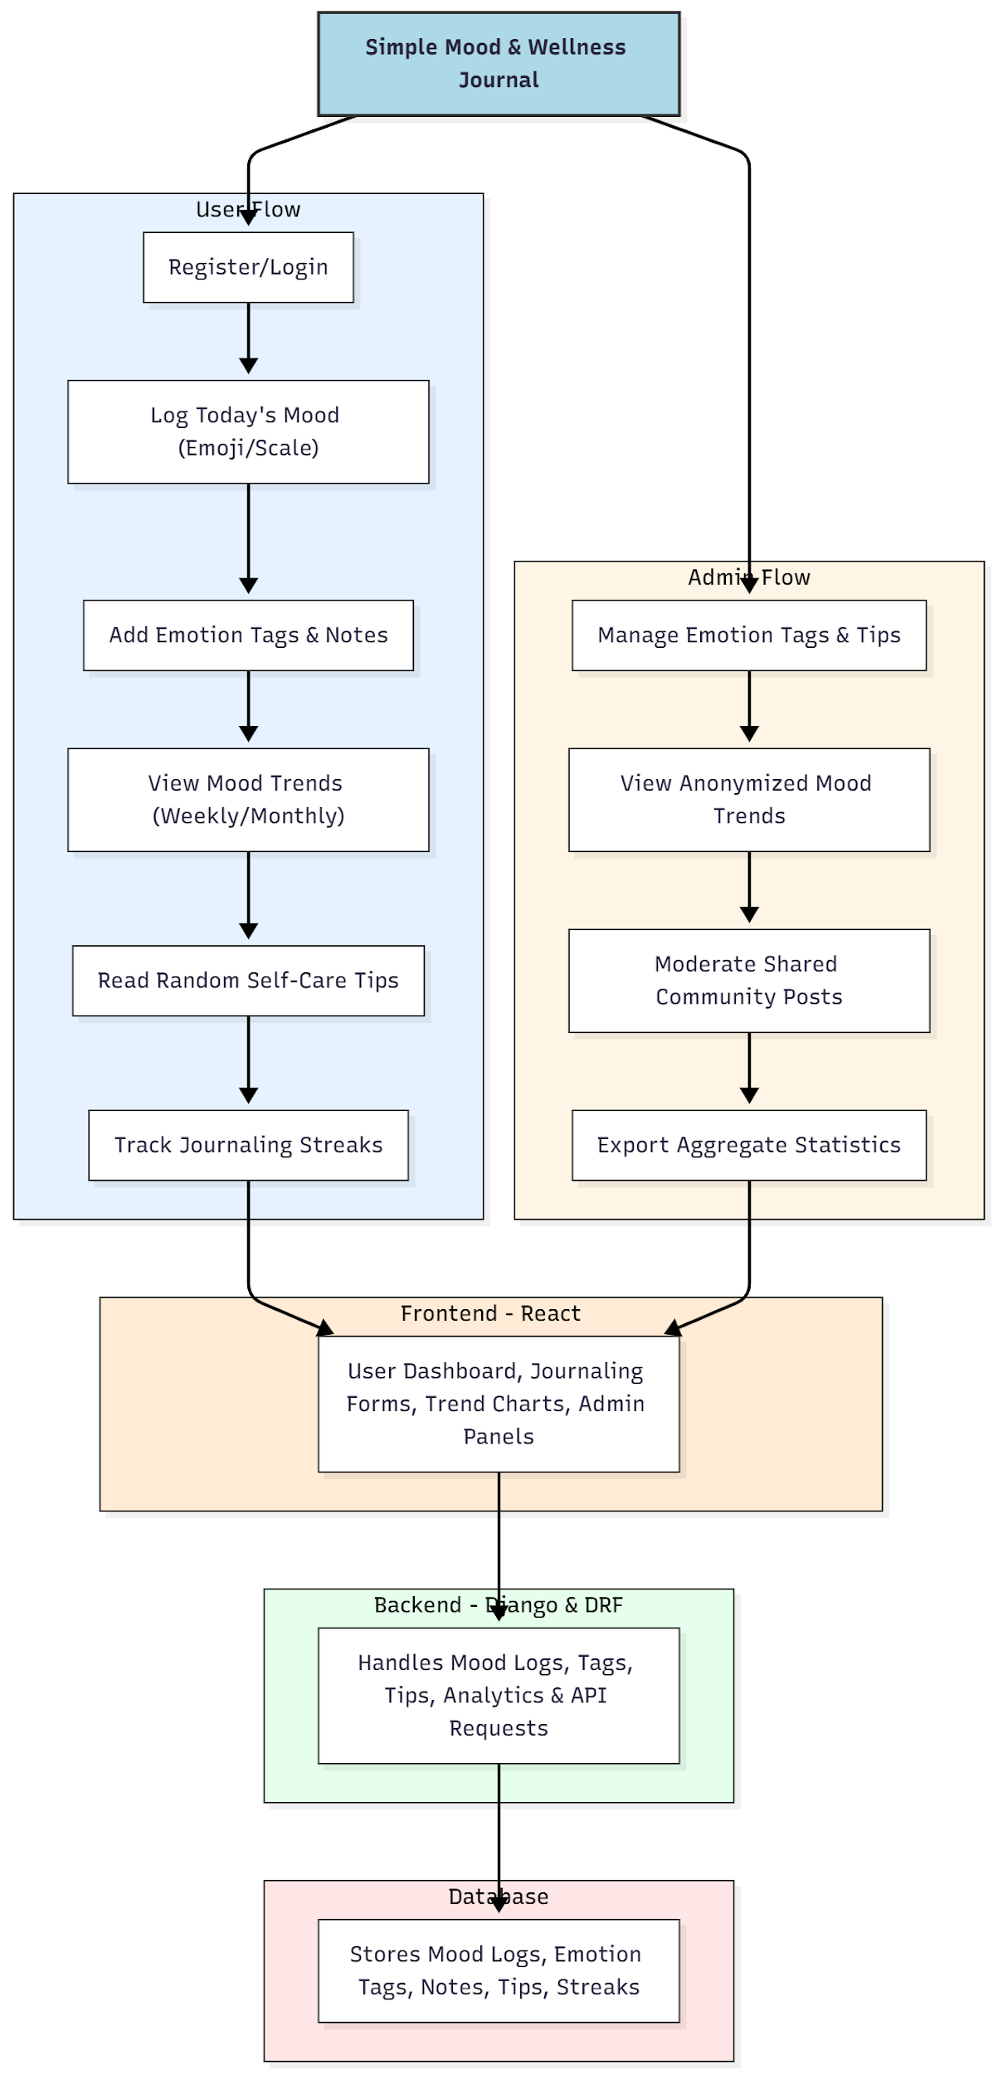

WORKING OF THE PROJECT:
Users register or log in to the portal and log their daily mood using an emoji or scale rating. They can add emotion tags and optional notes for more context. Trend charts visualize mood data over weeks or months, while self-care tips provide additional guidance. Journaling streaks motivate consistent logging.
Administrators manage the list of emotion tags and self-care tips, monitor anonymized trends for analytics, moderate shared posts (if enabled), and export aggregate statistics for reporting purposes. The backend manages API requests, stores structured mood data, computes trends, and ensures real-time updates on the frontend dashboards, creating a secure and insightful journaling experience..

SOFTWARE REQUIREMENT:
- Backend:
  - Python 3.x
  - Django
  - Django REST Framework
  - SQLite/PostgreSQL
- Frontend:
  - Node.js and npm
  - React.js
  - Axios
- Development Tools:
  - Visual Studio Code
  - Postman (for testing APIs)
  - Git/GitHub (for version control)
- Server/Deployment (Optional):
  - Gunicorn, Nginx, or Heroku/AWS for hosting

ADVANTAGES OF THE PROJECT:

• Facilitates structured mood and wellness tracking
• Encourages self-care through tips and journaling streaks
• Provides visual trend analytics for user awareness
• Secure storage and management of user data
• Allows administrators to moderate content effectively
• Supports both individual wellness and counseling centers
• Easy to export anonymized statistics for analysis
• Intuitive and user-friendly interface

APPLICATIONS OF THE PROJECT:
• Individual wellness and mental health tracking
• Counseling centers and therapy programs
• Self-care habit tracking for students or employees
• Community mental health initiatives
• Personal emotion and activity journaling

REFERENCES:

- Django REST Framework Documentation — Django Software Foundation. Django Documentation. Available: https://docs.djangoproject.com/
- Django REST Framework. DRF Documentation. Available: https://www.django-rest-framework.org/
- React. React Official Documentation. Available: https://reactjs.org/docs/getting-started.html
- Redux. Redux Documentation. Available: https://redux.js.org/introduction/getting-started
- PostgreSQL Global Development Group. PostgreSQL Documentation. Available: https://www.postgresql.org/docs/
- MySQL. MySQL Reference Manual. Available: https://dev.mysql.com/doc/
- Git. Git Documentation. Available: https://git-scm.com/doc
- Node.js. Node.js Documentation. Available: https://nodejs.org/en/docs/
- Axios. Axios Documentation. Available: https://axios-http.com/docs/intro
- Socket.io Documentation – https://socket.io/docs/

